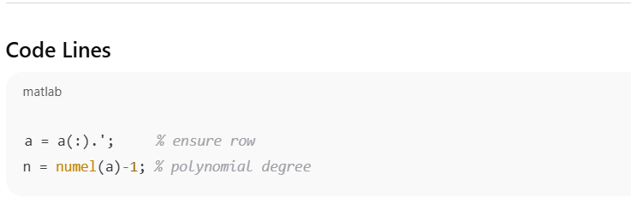
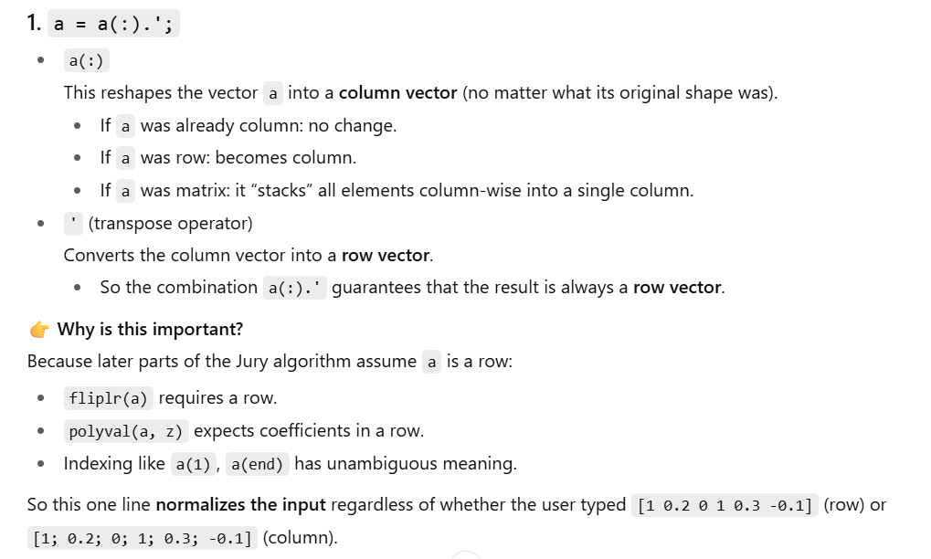
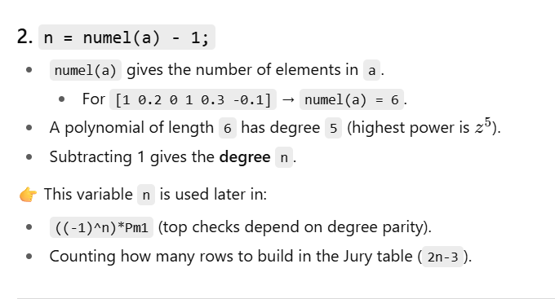
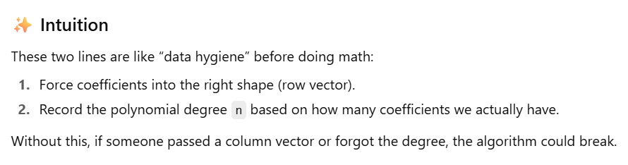
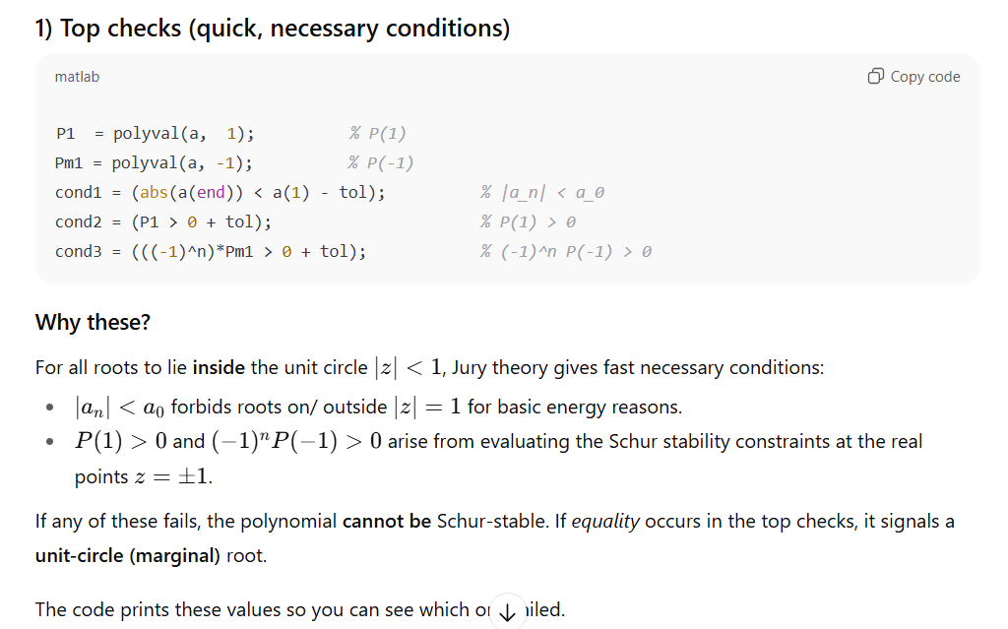
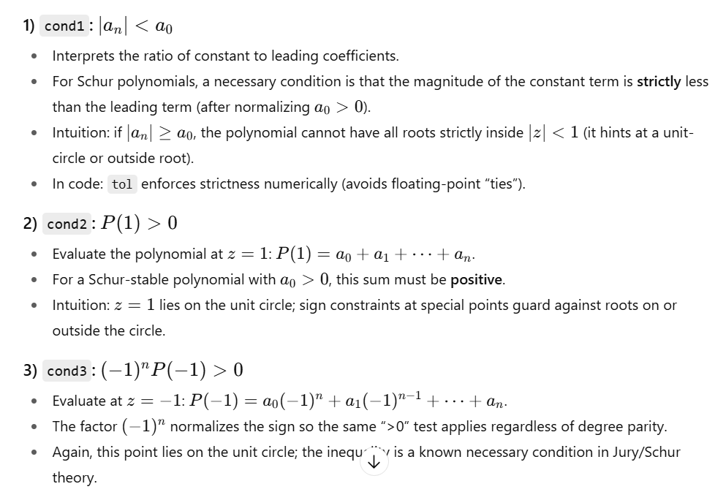
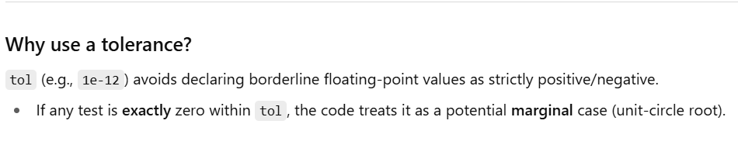
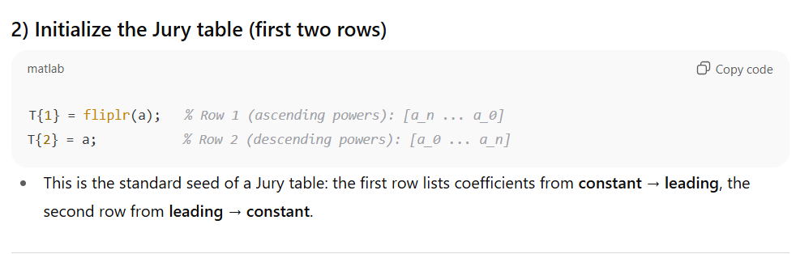
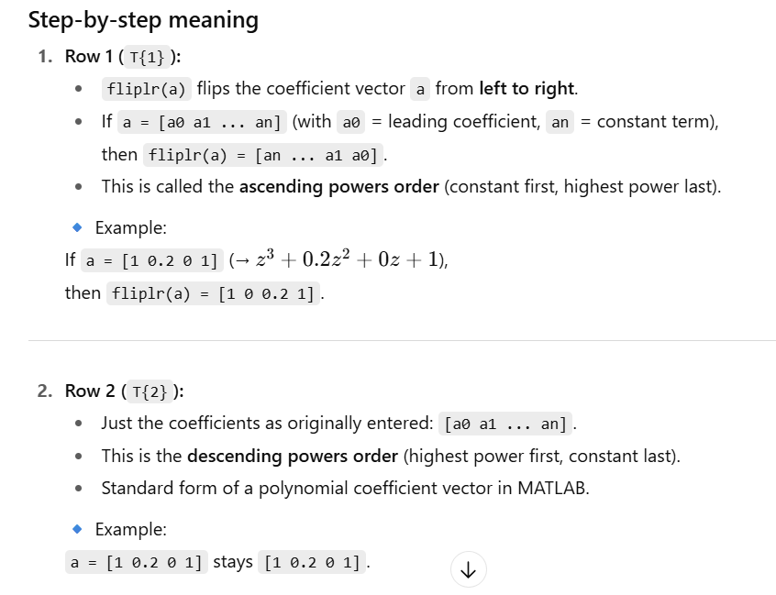
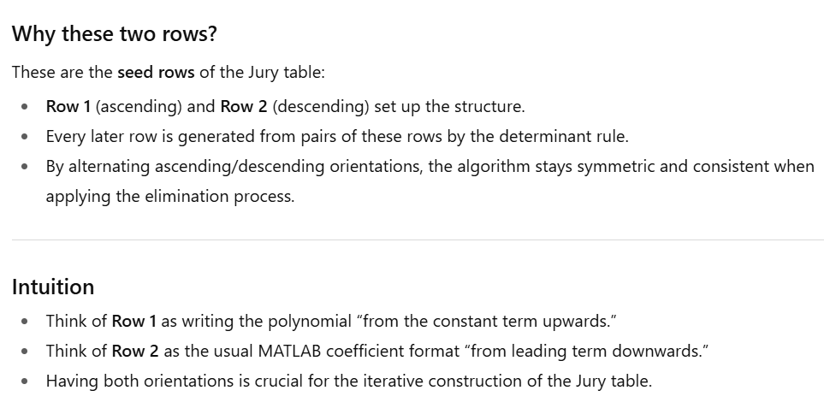
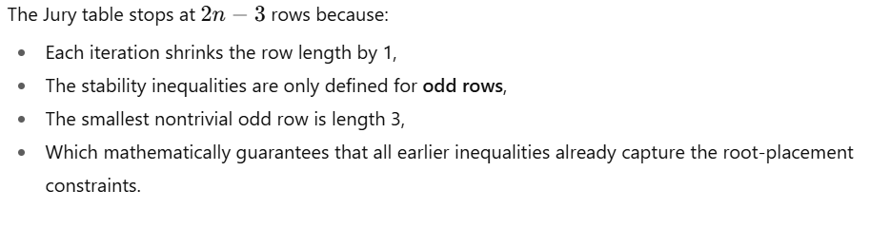
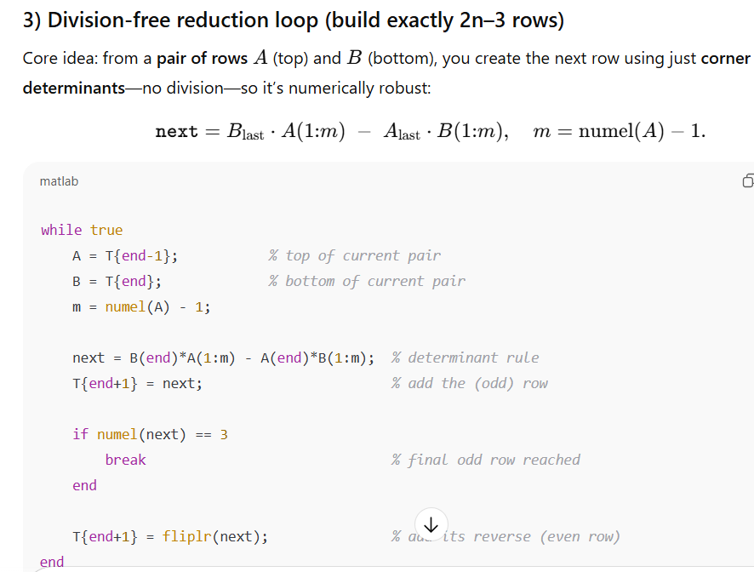
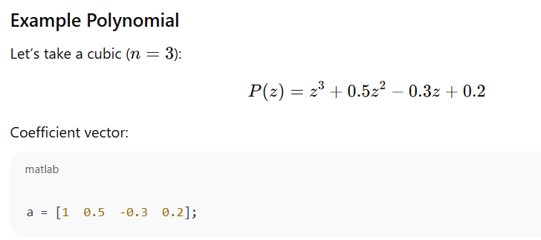
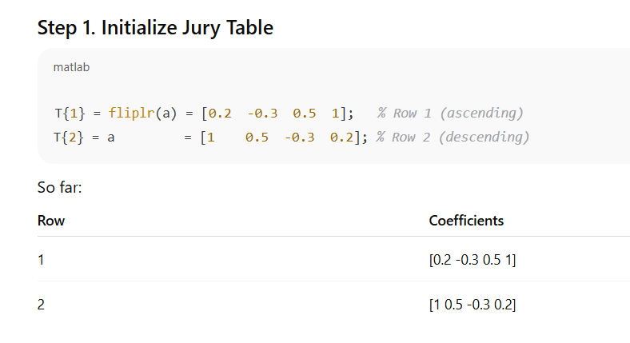
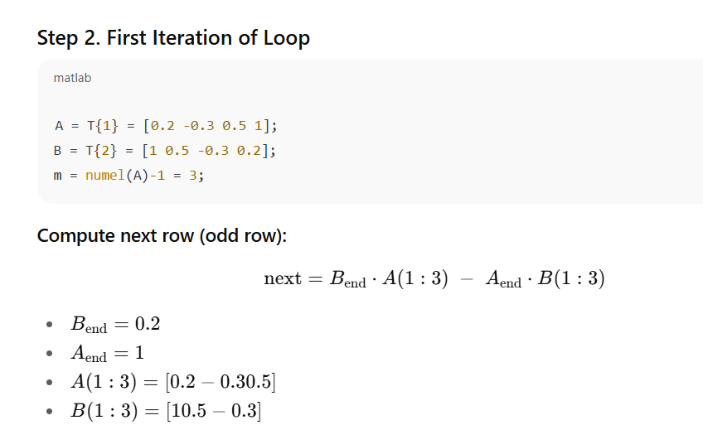
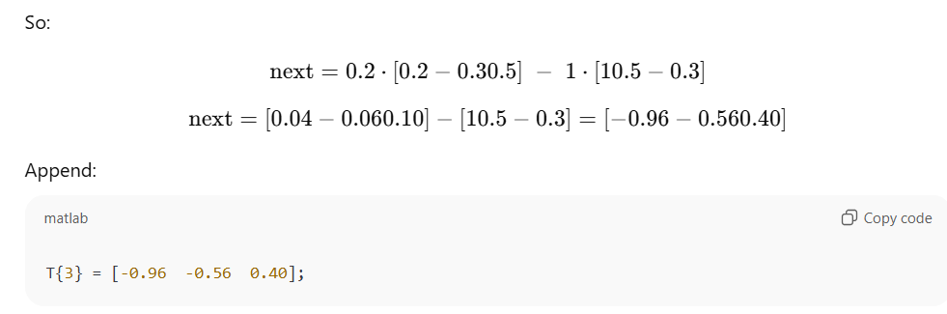
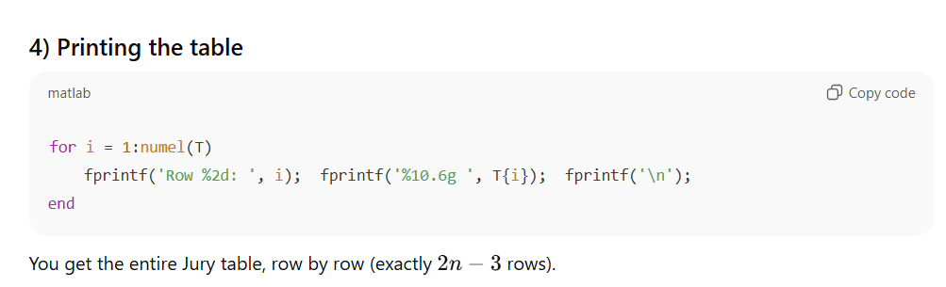
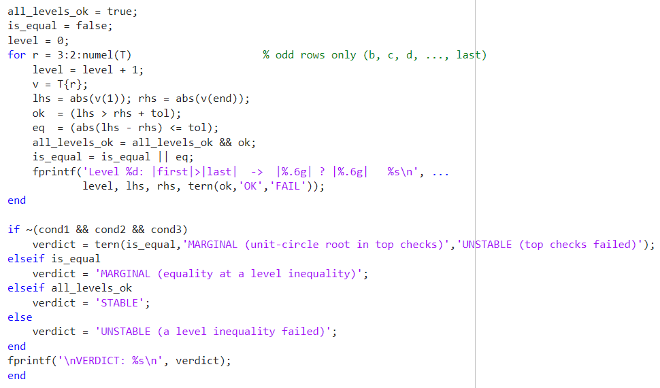
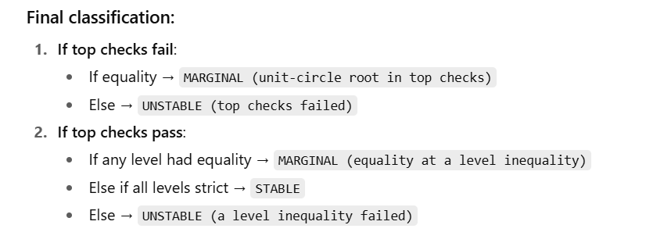
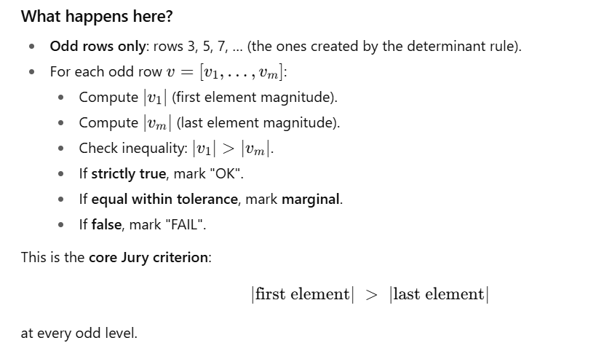

function jury_table(a)
% JURY_TABLE Create textbook-style Jury table for any polynomial.
% Usage: jury_table([a0 a1 ... an]) % a0 = coeff of z^n
% Example: jury_table([1 0.2 0 1 0.3 -0.1])

a = a(:).'; % ensure row
n = numel(a)-1;

% --- Top checks ---
P1 = polyval(a, 1);
Pm1 = polyval(a, -1);
fprintf('P(1) = %.6g\n', P1);
fprintf('(-1)^n P(-1) = %.6g\n', ((-1)^n)*Pm1);
fprintf('|a_n| < a_0 -> %d (|a_n|=%.6g, a0=%.6g)\n\n', abs(a(end))<a(1), abs(a(end)), a(1));

% --- Build Jury table (Row1 ascending, Row2 descending) ---
T = {};
T{1} = fliplr(a); % Row 1
T{2} = a; % Row 2

% Determinant-based reduction (NO division)
% Build exactly 2n-3 rows: stop after adding the final 3-element odd row
while true
A = T{end-1}; % top of current pair
B = T{end}; % bottom of current pair
m = numel(A) - 1; % next odd row length

next = B(end)*A(1:m) - A(end)*B(1:m); % corner-determinant rule
T{end+1} = next; % add odd row (b, c, d, ...)

if numel(next) == 3 % reached last odd row -> STOP
break
end

T{end+1} = fliplr(next); % add its reverse (even row) and continue
end

% --- Print Jury table (exactly 2n-3 rows) ---
fprintf('--- JURY TABLE (2n-3 rows) ---\n');
for i = 1:numel(T)
fprintf('Row %2d: ', i);
fprintf('%10.6g ', T{i});
fprintf('\n');
end
fprintf('\n');

% --- Validation for stability ---
tol = 1e-12;
cond1 = (abs(a(end)) < a(1) - tol);
cond2 = (P1 > 0 + tol);
cond3 = (((-1)^n)*Pm1 > 0 + tol);

all_levels_ok = true;
is_equal = false;
level = 0;
for r = 3:2:numel(T) % odd rows only (b, c, d, ..., last)
level = level + 1;
v = T{r};
lhs = abs(v(1)); rhs = abs(v(end));
ok = (lhs > rhs + tol);
eq = (abs(lhs - rhs) <= tol);
all_levels_ok = all_levels_ok && ok;
is_equal = is_equal || eq;
fprintf('Level %d: |first|>|last| -> |%.6g| ? |%.6g| %s\n', ...
level, lhs, rhs, tern(ok,'OK','FAIL'));
end

if ~(cond1 && cond2 && cond3)
verdict = tern(is_equal,'MARGINAL (unit-circle root in top checks)','UNSTABLE (top checks failed)');
elseif is_equal
verdict = 'MARGINAL (equality at a level inequality)';
elseif all_levels_ok
verdict = 'STABLE';
else
verdict = 'UNSTABLE (a level inequality failed)';
end
fprintf('\nVERDICT: %s\n', verdict);
end

% --- helper ---
function s = tern(tf,a,b), if tf, s=a; else, s=b; end
end

